**IMG METAGENOMES HANDS ON EXERCISES (MGM-23)**

**EXERCISE 1**

**Observation:**Thiocyanate (SCN−), a cyanide derivative with lower toxicity, is produced at high concentrations in gold mining effluents and other industrial processes. Biological degradation of contaminated wastewater can completely remove SCN− and co-contaminants, such as CN−. Degradation pathways include (i) an autotrophic pathway, where SCN− is a source of energy, sulfur and nitrogen, and ammonium and carbonyl sulfide (OCS) are produced, and (ii) a heterotrophic pathway where SCN− is the sole nitrogen source with growth on organic carbon. However, little is known about the metabolic potential of SCN− degrading consortia. Let’s explore the key microbes responsible for SCN− degradation using metagenomics.



Kantor, R.S. et. al. **Bioreactor microbial ecosystems for thiocyanate and cyanide degradation unraveled with genome-resolved metagenomics.** Environmental Microbiology 2015, 17(12): 4929-4941.

**Objectives:** Discover the key microbial players responsible for SCN− degradation from a bioreactor time-series metagenomic study. Use the following metagenomes for this analysis: 3300003408, 3300003402, 3300003406, 3300003485, 3300005643, 3300006095, 3300009070

* What is the phylogenetic distribution of these bioreactor consortia using a cumulative 30% identity threshold? (Hint: make sure to use “Estimated gene copies” to normalize data across metagenomes) What are the main differences in phylogenetic distribution across the 7 metagenomes?
* Are the differences that were observed in the phylogenetic distribution also apparent at the functional level using KEGG Orthologs? (Hint: Look at *Genome Clustering*)
* In *Thiobacillus thioparus* DSM 505, the enzyme thiocyanate hydrolase (SCNase) is known to convert SCN− to carbonyl sulfide (COS) and ammonium. Do any of the metagenomes recruit the *Thiobacillus thioparus* DSM 505 genome? (Hint: Look at *Genome vs. Metagenomes*)
* Identify the thiocyanate hydrolase (SCNase) in the *Thiobacillus thioparus* DSM 505 genome. What is the associated pfam for the thiocyanate hydrolase and how many are encoded across the seven metagenomes?

**Workflow:** *Add the 7 metagenomes to the Genome Cart. Under the “****Compare Genomes****” tab, select “****Phylogenetic Distribution****” and “****Metagenomes vs. Genomes****.” For Display options, select Percent Identity “****30+****” since we are interested in all cumulative hits > 30%. Also select “****Estimated gene copies****” for the correct normalization of the 7 metagenomes. Click “****Go****.”*

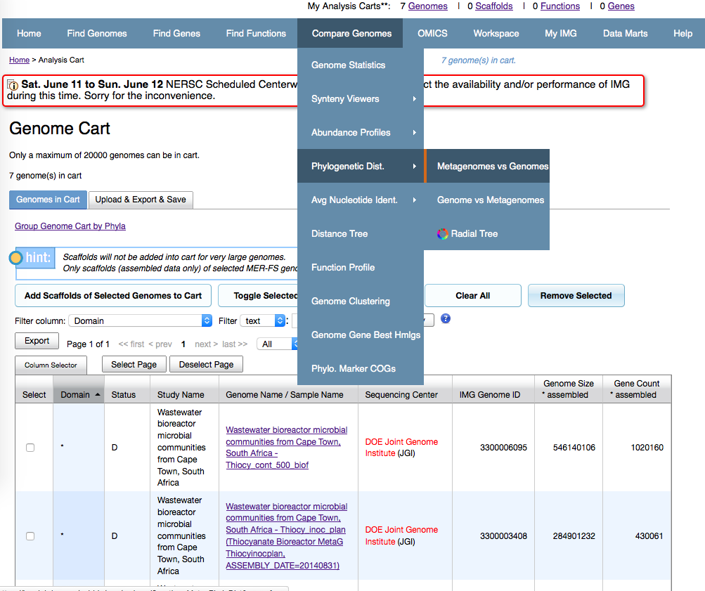

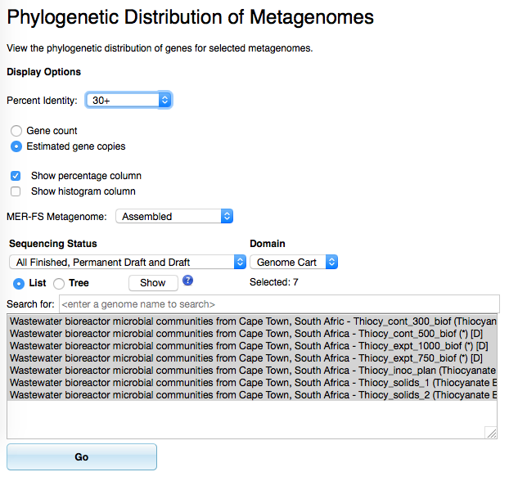

*A large table will be displayed with the gene distribution and percentages by phyla. Either explore this table, or scroll to the bottom of the screen and click “****Bar chart****” to display the data as a bar chart.*

**

*Viewing the bar chart, you can easily pick out the dominant phyla represented in the 7 metagenomes: Proteobacteria, Bacteroidetes, and Actinobacteria.*

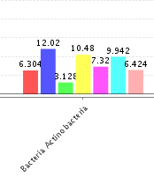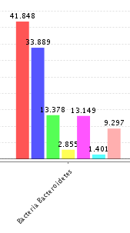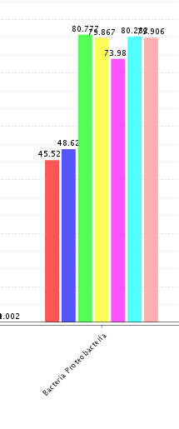

*It is very clear to see that the main differences in phylogenetic distribution are the two “Thiocy_solids” metagenomes (red and blue) compared to the other time series samples. These are enriched in Bacteroidetes, while the five other time series metagenomes are enriched in Proteobacteria.*

*Next, use the “****Compare Genomes****” > “****Genome Clustering****” to get a picture of the overall functional differences across the metagenomes. Add all 7 metagenomes to the analysis, select “****KO****” to cluster by KEGG orthologs and select “****PCA****” as clustering method.*

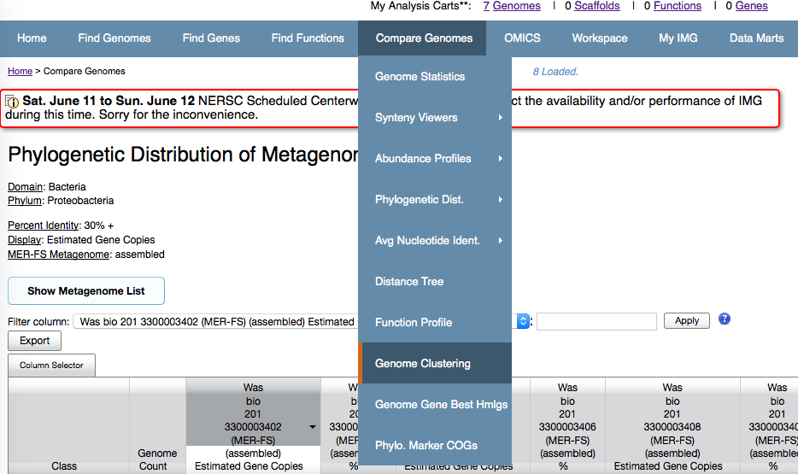

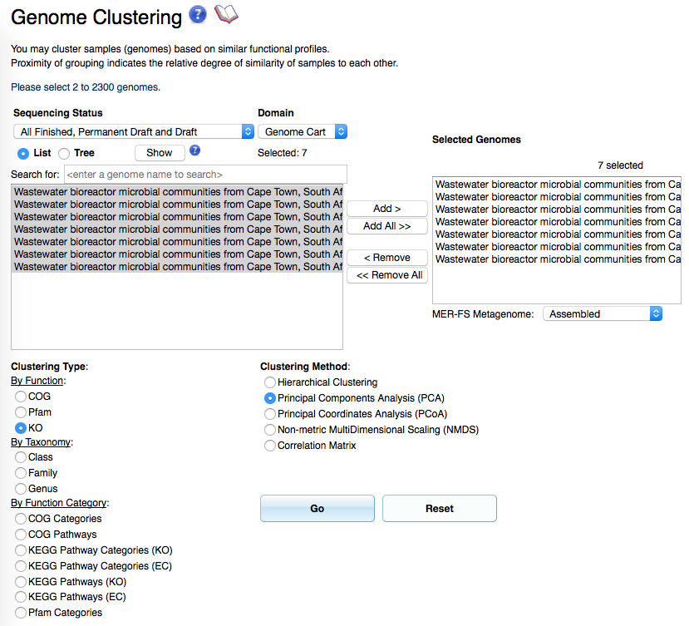

*A 3D PCA plot will be displayed. Similar results will be depicted if other clustering methods are used (eg. Hierarchical Clustering, PCoA, NMDS or Correlation Matrix). As with the phylogenetic profile for the 7 metagenomes, we see the two “Thiocy_solids” metagenomes cluster together based on their similar KO functional profile.*

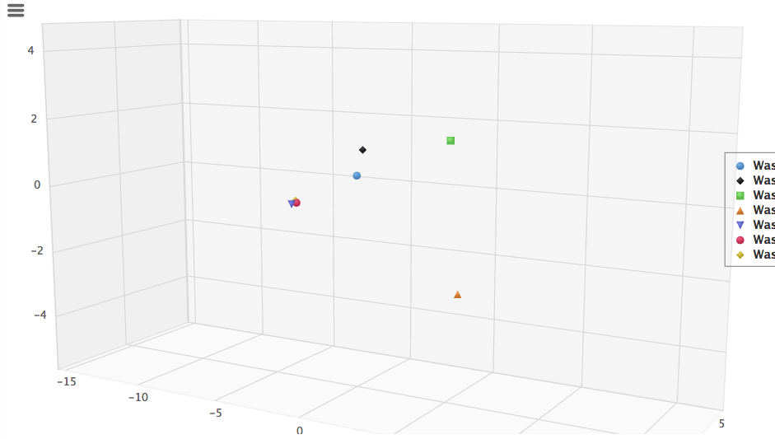

*We next want to see if any of the metagenomes recruit the Thiobacillus thioparus DSM 505 genome. Add the Thiobacillus thioparus DSM 505 to your genome cart and use the “****Compare Genomes****” >* ***“Phylogenetic Dist”*** *>* ***“Genome vs. Metagenomes.”***

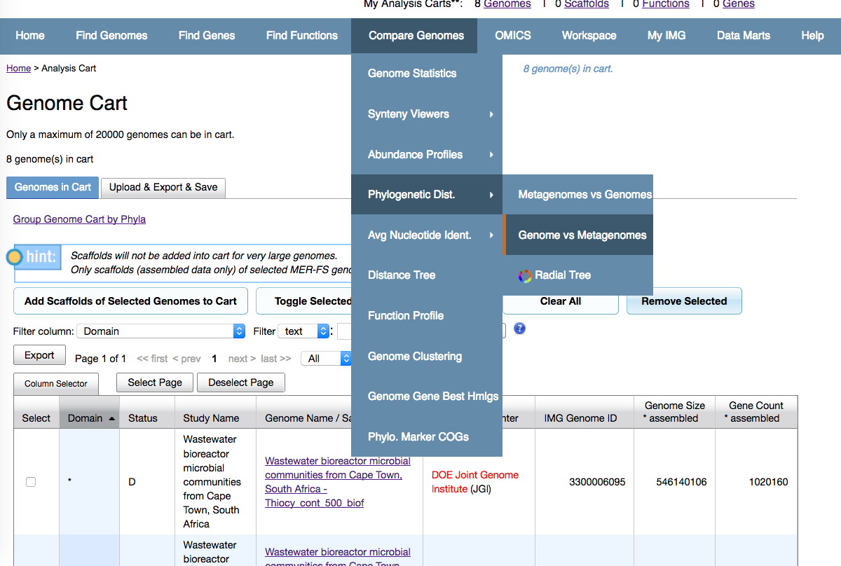

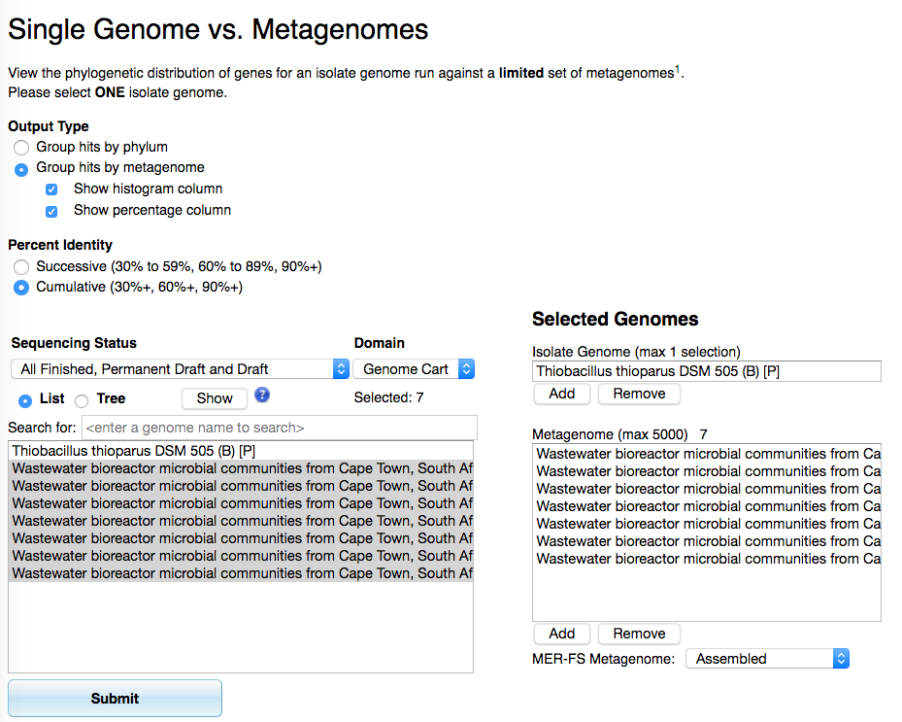

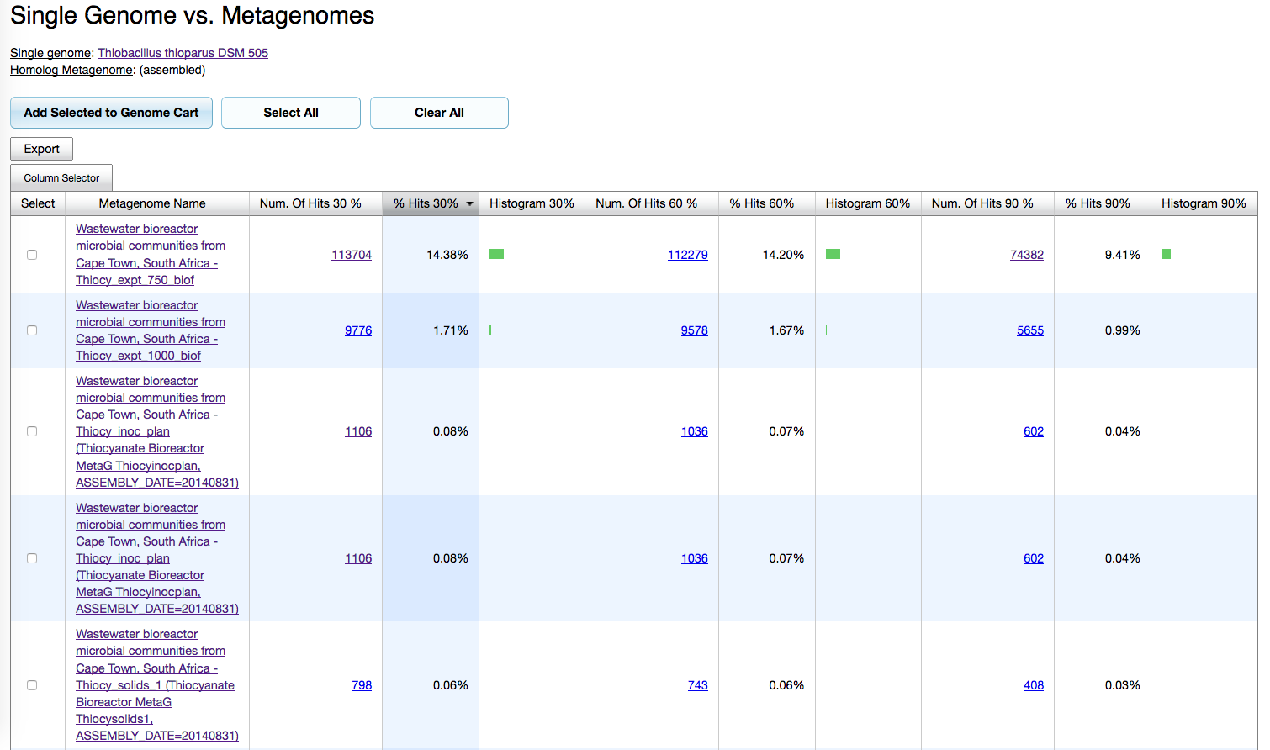

*Lastly, we want to identify the thiocyanate hydrolase gene (SCNase) in the Thiobacillus thioparus DSM 505 genome and search across the metagenomes using the pfam. Use the “****Find Genes****” >* ***“Gene Search”*** *function and type in “****thiocyanate hydrolase****” with the filter “****Gene Product Name (inexact)****.”*

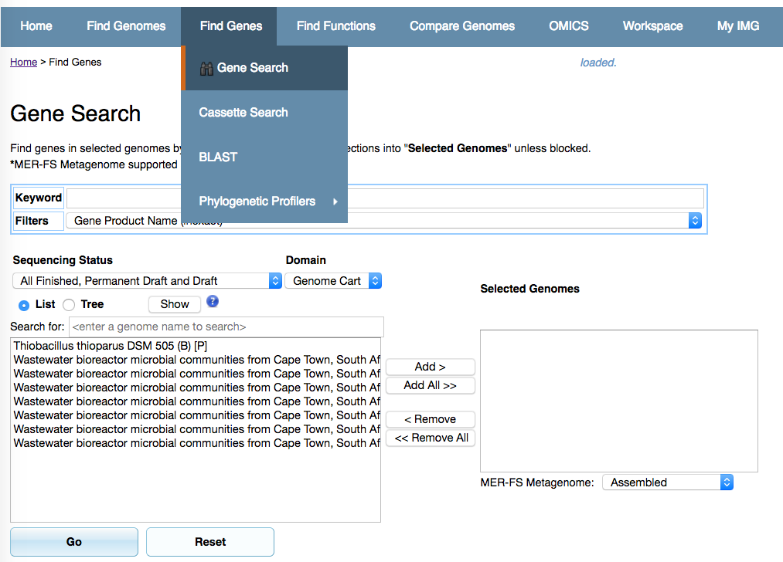

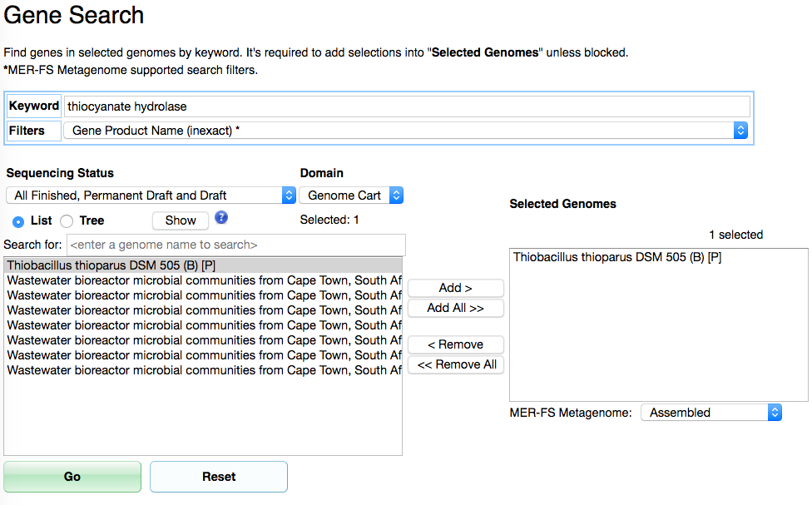

*From the thiocyanate hydrolase gene page, scroll down and identify the predicted pfam, pfam02979 - NHase_alpha.*

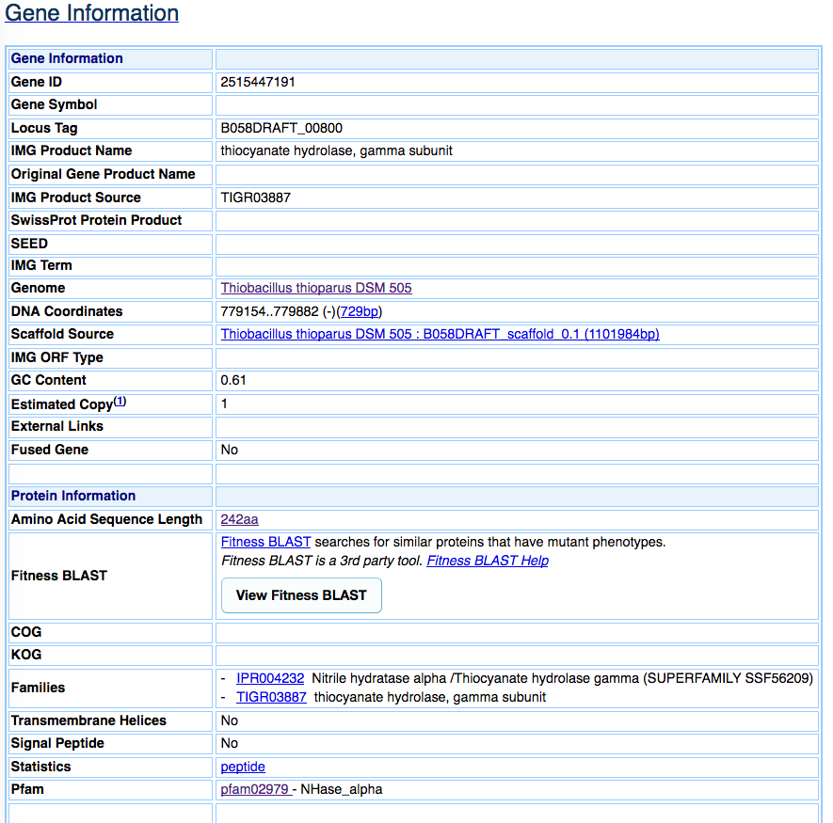

*To search for pfam02979 across the seven metagenomes, use the “****Find Functions****” > “****Function Search****.” Type in “pfam01979” with the filter “****Pfam (list)****,” then select the seven metagenomes to search.*

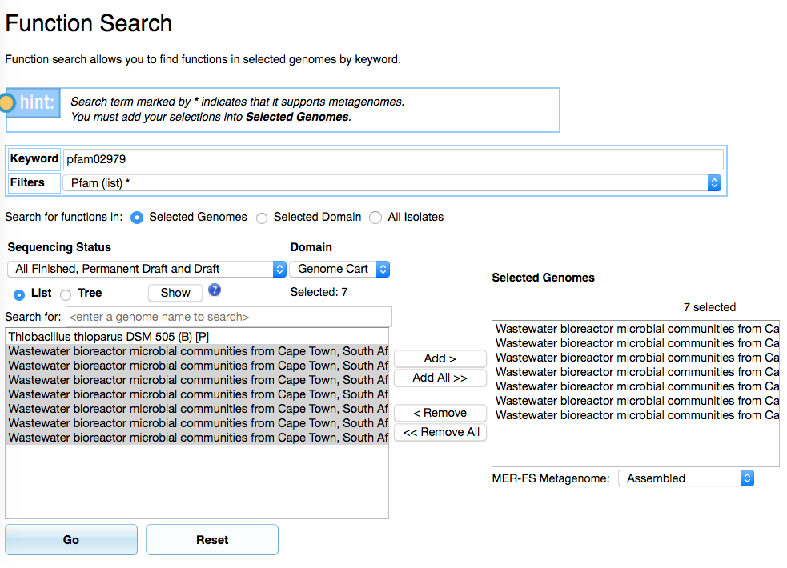

*There are a total of 147 genes annotated with pfam02979.*

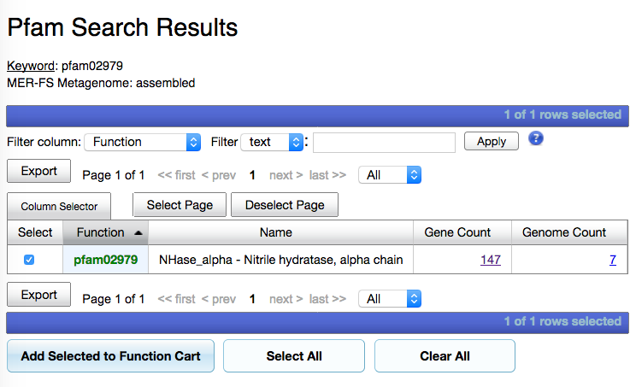

**Result:** Community analysis revealed a dominance of the phyla Proteobacteria, Bacteroidetes, and Actinobacteria. There were differences between the time-series metagenomes and the two “Thiocy_solids” metagenomes both in terms of phylogenetic distribution and functional properties. Further, one of the metagenomes recruited the *Thiobacillus thioparus* DSM 505 genome and all of them encoded multiple genes annotated with pfam02979.

**EXERCISE 2**

**Observation:**The ubiquitous Group I marine Thaumarchaeota are among the most abundant organisms in the global oceans, and carry out important biogeochemical cycling including ammonia oxidation. *Nitrosopumilus maritimus* SCM1 was the first member of this lineage to be cultured in the laboratory and has served as an important experimental model. Recently, *N. maritimus* was discovered to encode a pathway for methylphosphonate biosynthesis and is thought to contribute to the “methane paradox” in the global oceans, an unsolved observation where much of the aerobic ocean is supersaturated with methane (Metcalf et al 2012). Let’s explore the key gene for methylphosphonate biosynthesis in this important marine microbe and across marine metagenomes.

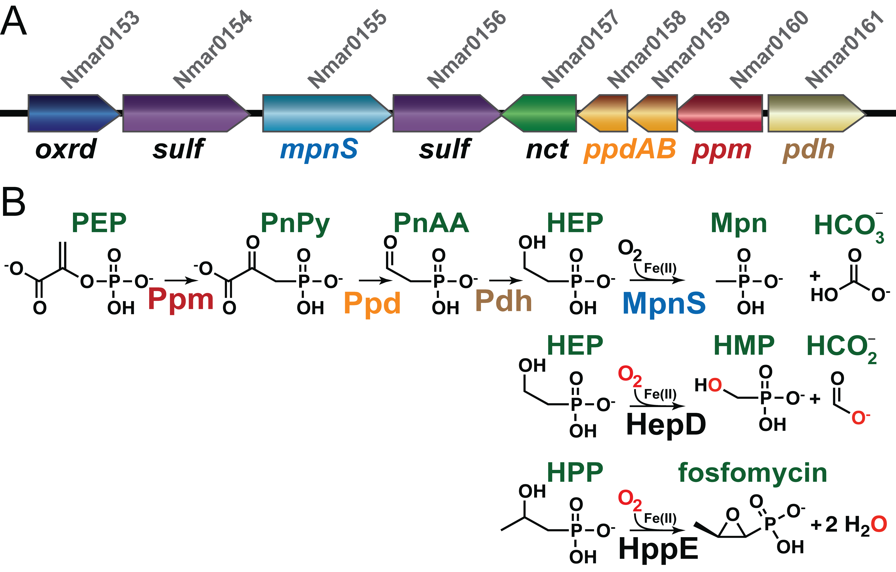

Metcalf, W.W. et. al. **Synthesis of methylphosphonic acid by marine microbes: a source for methane in the aerobic ocean.** Science 2012, 337(6098): 1104-1107.

**Objectives:** Discover the key gene for methylphosphonate biosynthesis across marine metagenomes. (Before getting started, remember to clear all carts from previous exercise!)

* Retrieve the amino acid sequence for the methylphosphonate synthase (*mpnS*) from *N. maritimus* SCM1*.* (Hint: the KO term for mpnS is K18049.)
* Are there any homologs to mpnS in the global oceans? Let’s first try to BLAST the *N. maritimus mpnS* sequence to a metagenome from the Global Ocean Sampling (GOS) Expedition collected from Key West, Florida (IMG Taxon ID: 3300001953).
* What other gene is encoded on the scaffold encoding a putative *mpnS* and what is the taxonomic affiliation?
* Search for the *mpnS* KO function K18049 across all oceanic metagenomes. (Hint: Use Genome Search > by Metadata Category Operation > Select metadata categories Ecosystem: “Environment” and Ecosystem Subtype: “Oceanic”; also, be careful to only select metagenomes, not metatranscriptomes! Filter by “metaT” to remove metatranscriptomes) How many metagenomes encode more than 100 predicted methylphosphonate synthase genes? What is the largest number of matches in a single metagenome to this function?

**Workflow:** *To retrieve the amino acid sequence for the methylphosphonate synthase (mpnS) from N. maritimus use the “****Find Functions****” > “****Function Search****” since we are provided with the KO term. (There are, of course, alternate ways to get to the mpnS gene page!) Type in “K18049” as the Keyword and select the filter “****KEGG Orthology ID (list).****” Search and select the N. maritimus SCM1 genome from the list of archaeal genomes, then click “****GO****.”*

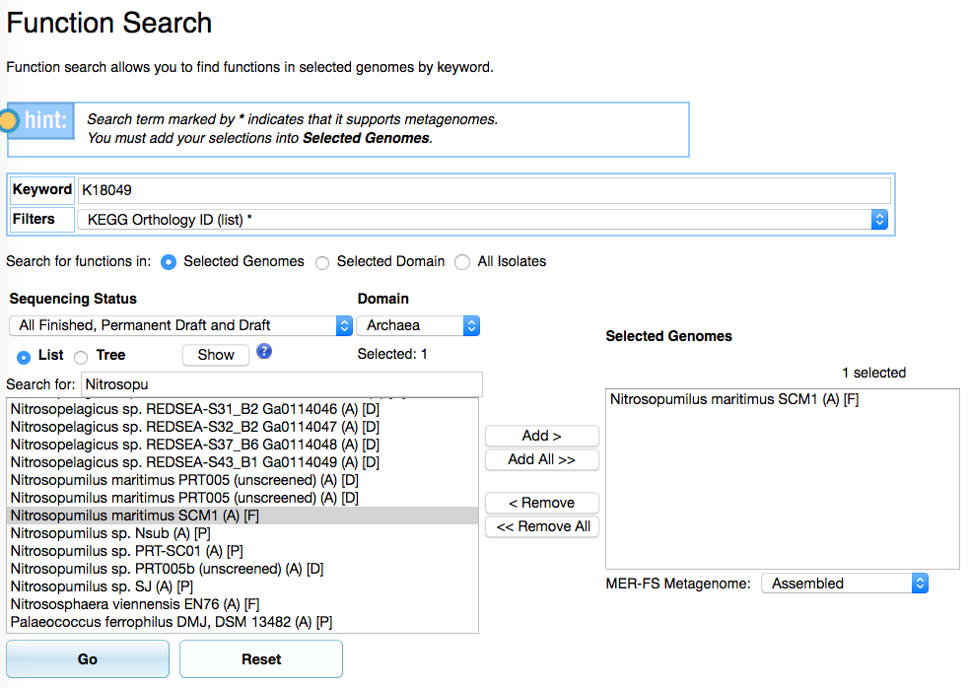

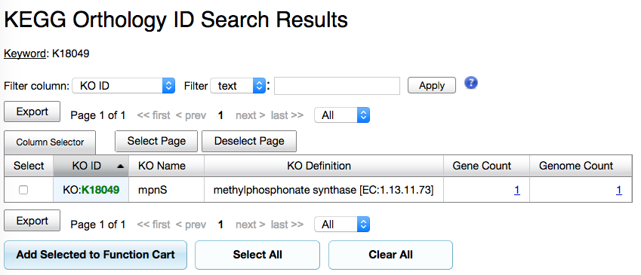

*Once on the Gene Page, scroll down to the Amino Acid Sequence Length, where you will find a link to the protein fasta file. Copy the amino acid sequence for the N. maritimus* SCM1mpnS*.*

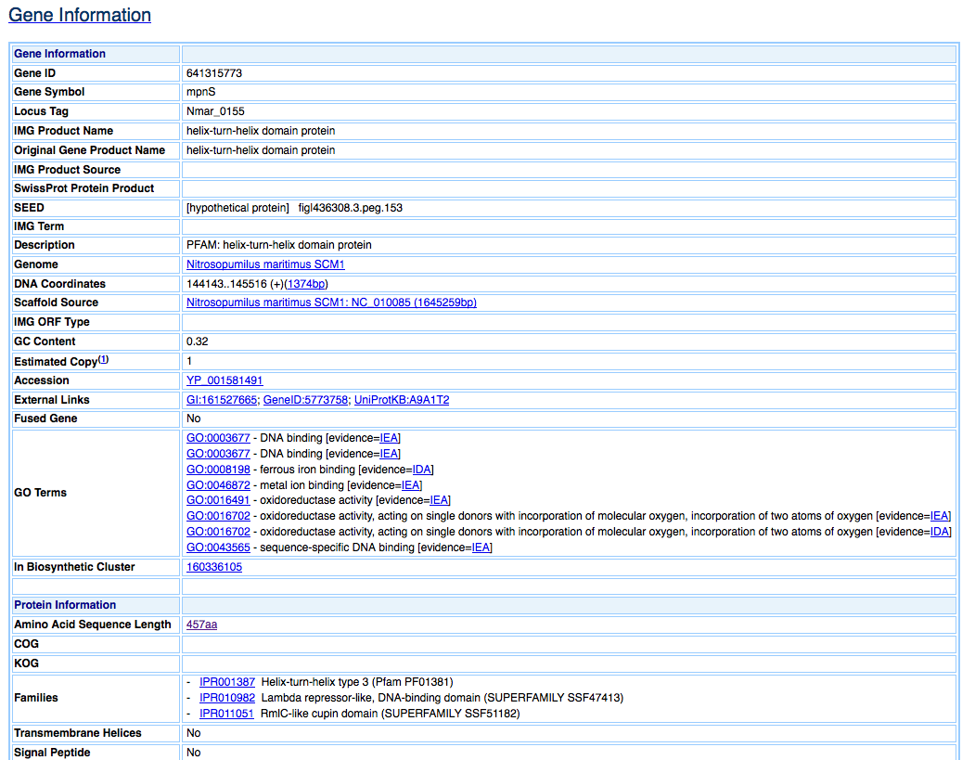

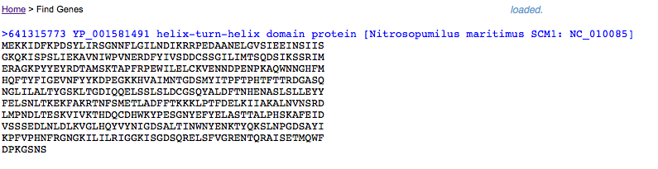

*We are next going to use BLAST to search for homologs to mpnS in one of the marine metagenomes (IMG taxon ID: 3300001953). Add this metagenome to your Genome Cart. Go to the “****Find Genes****” and “****BLAST****” page. Paste the copied protein sequence into the sequence box, select the marine metagenome to search and click “****GO****.”*

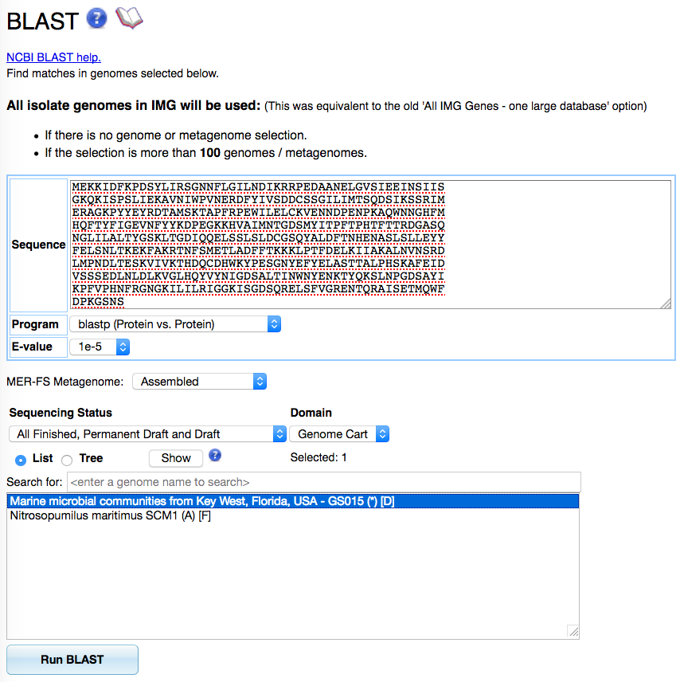

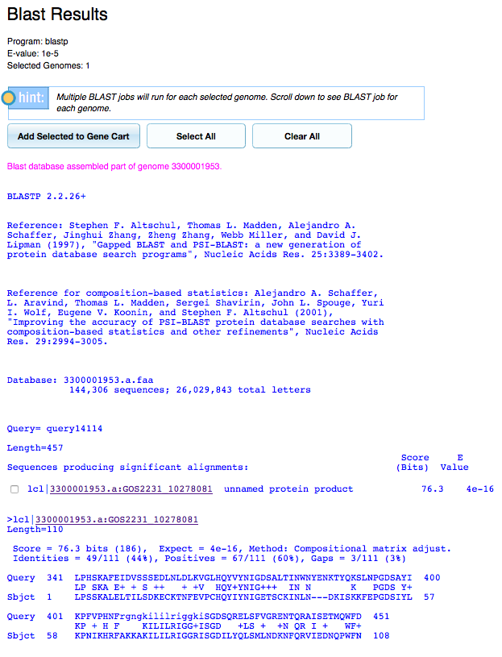

*Click on the single gene match to navigate to the Gene Page.*

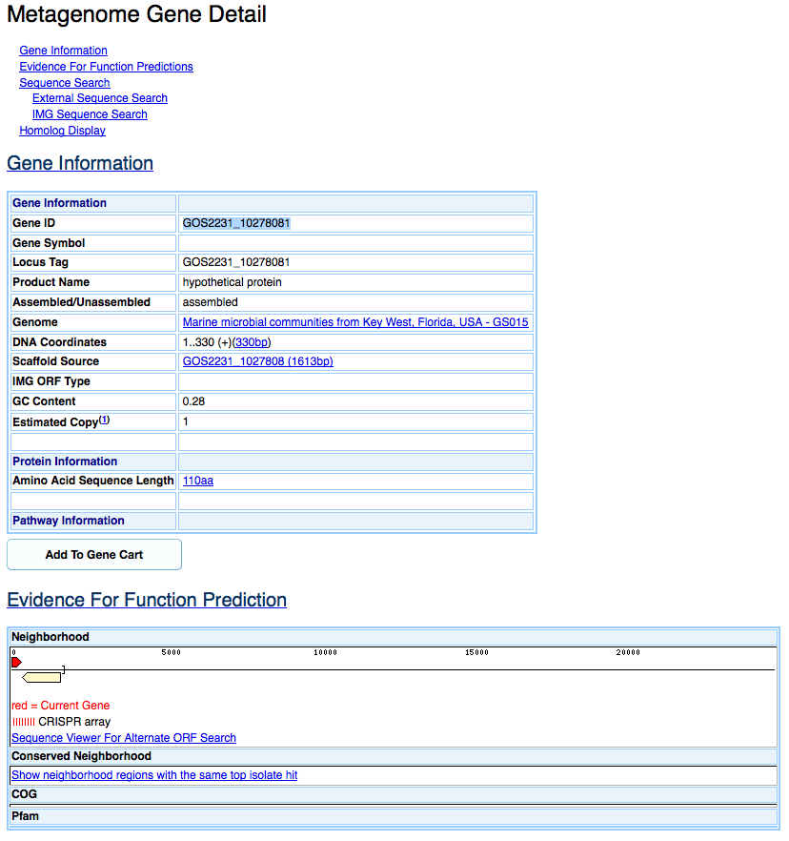

*The other gene encoded on the scaffold is a 23S rRNA gene (Locus Tag ID: GOS2231_10278082).*

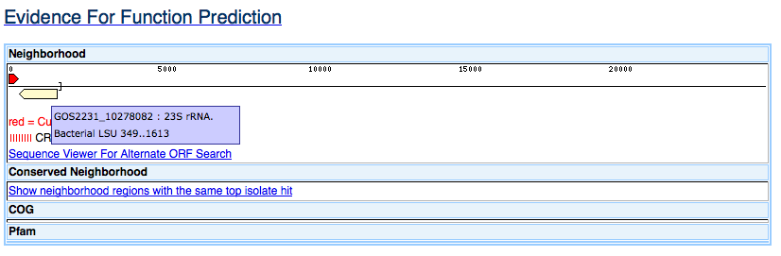

*Click on the 23S rRNA gene and then select Top IMG Isolate RNA Hits from the RNA Homologyto infer the taxonomic affiliation. The best isolate genome match is to Candidatus Pelagibacter ubique HIMB058. We can infer that the metagenomic scaffold likely derived from Candidatus Pelagibacter.*

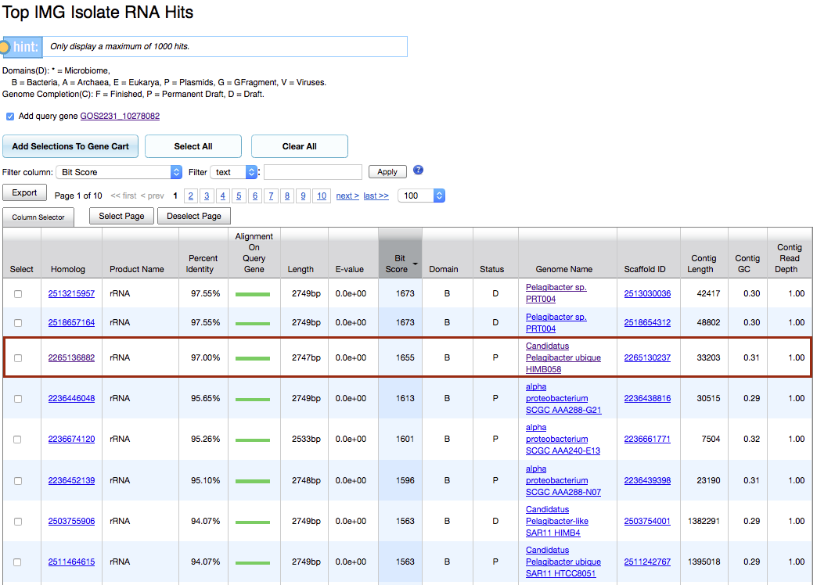

*Next, we want to explore this function across multiple metagenomes. While BLAST would be one way to go, we are limited to only searching against 20 metagenomes at a time. But we want to explore across ALL oceanic metagenomes. To do so, we will use the Function Cart and add all oceanic metagenomes using the Metadata search. First, find and add the KO function to the Function Cart. Use the “****Function Search****” to add KO: K18049 to the Function Cart.*

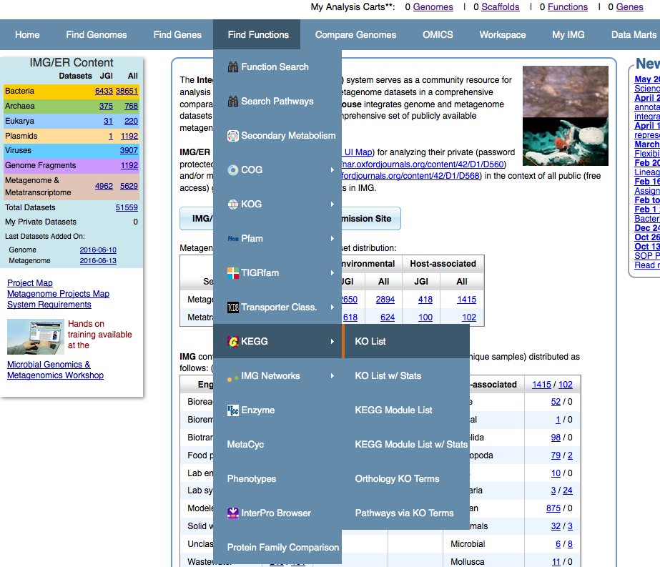

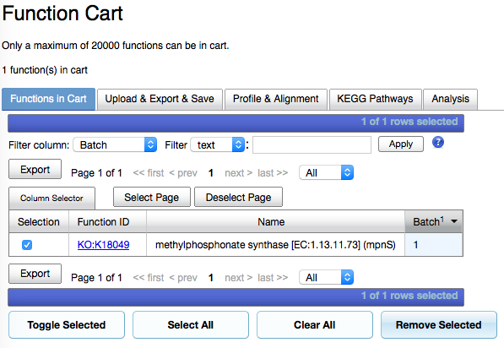

*Go to the “****Find Genomes****” tab and select “****Genome Search****.” Since we are interested in oceanic metagenomes, use the “****by Metadata Category Operation****” to select metadata categories Ecosystem: “****Environment****” and Ecosystem Subtype: “****Oceanic****.” (Warning: this will select isolate genomes too! Make sure to filter the results using “****\*****” to specify Metagenomes in the Domain column.) A total of 543 metagenomes (and metatranscriptomes!) will be loaded into your Genome Cart.*

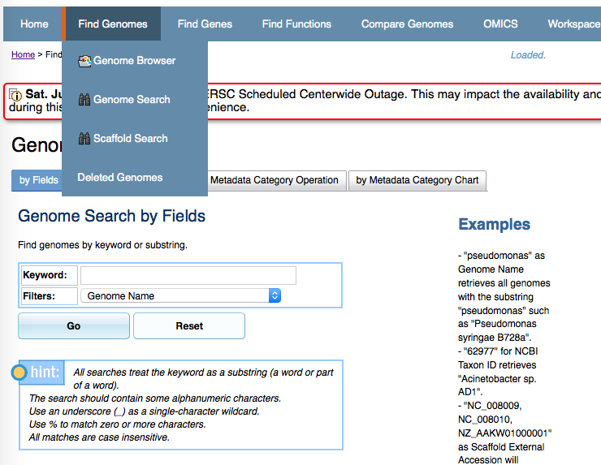

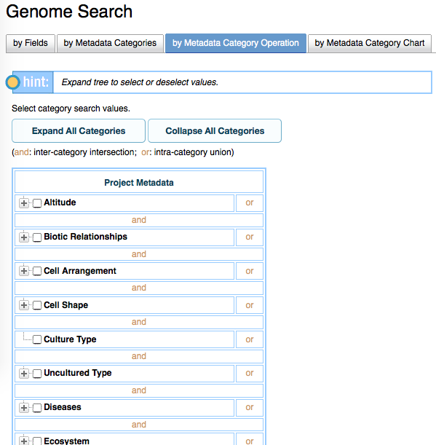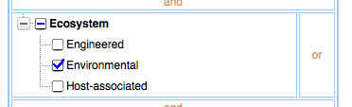

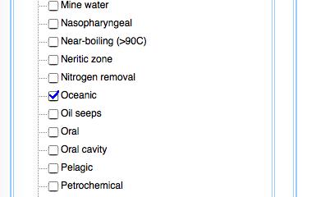

*However, we only want to look at metagenomes, not metatranscriptomes! From the Genome Cart, filter by “metaT” to list metatranscriptomes and then click “Select All” and “Remove Selected” to remove metatranscriptomes. There are now a total of 401 metagenomes.*

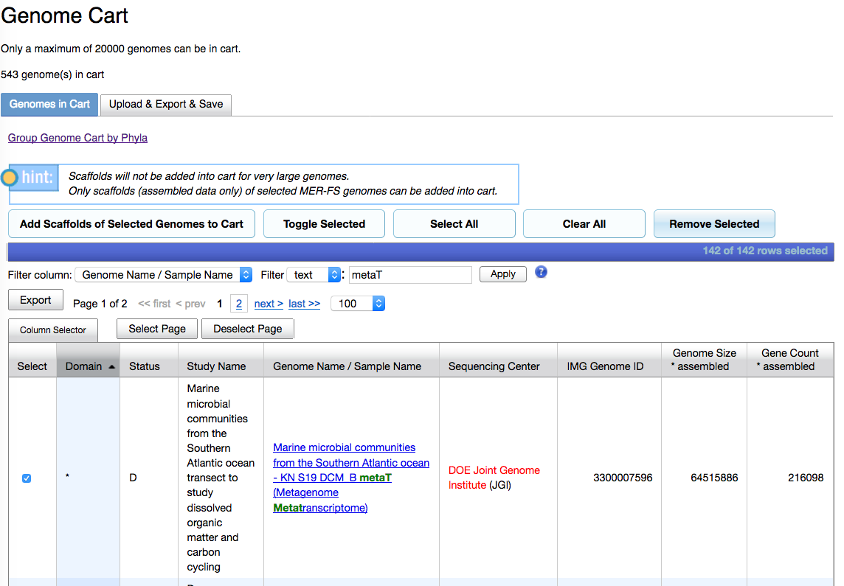

*Finally, go to the “****Compare Genomes****” and “****Function Profile****” to search all 401 metagenomes for the single function KO:K18049. Click the “****View Genomes vs. Functions****” to run the search against all metagenomes.*

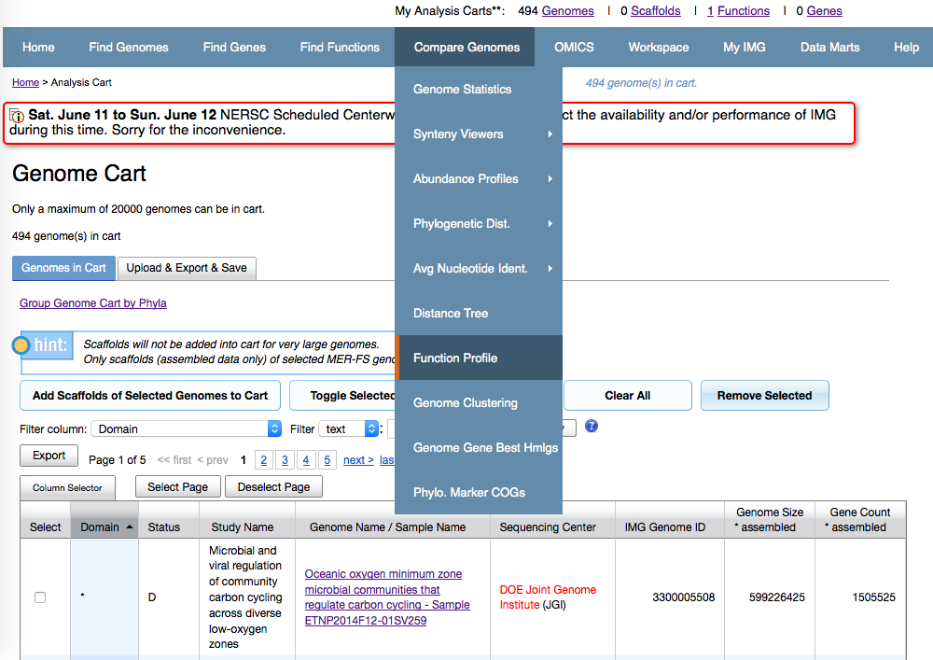

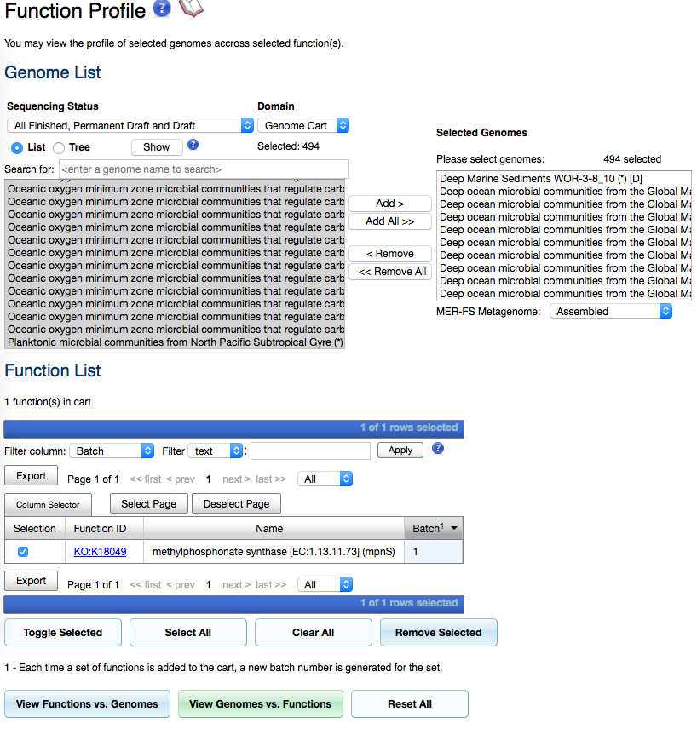

*This will display the number of hits to the KO function. Click the KO tab header to sort the number of hits. There are a total of 12 metagenomes (out of 401 searched) that have more than 100 matches to the methylphosphonate synthase K18049 function. The largest number of matches to this KO in a single metagenome is 175.*

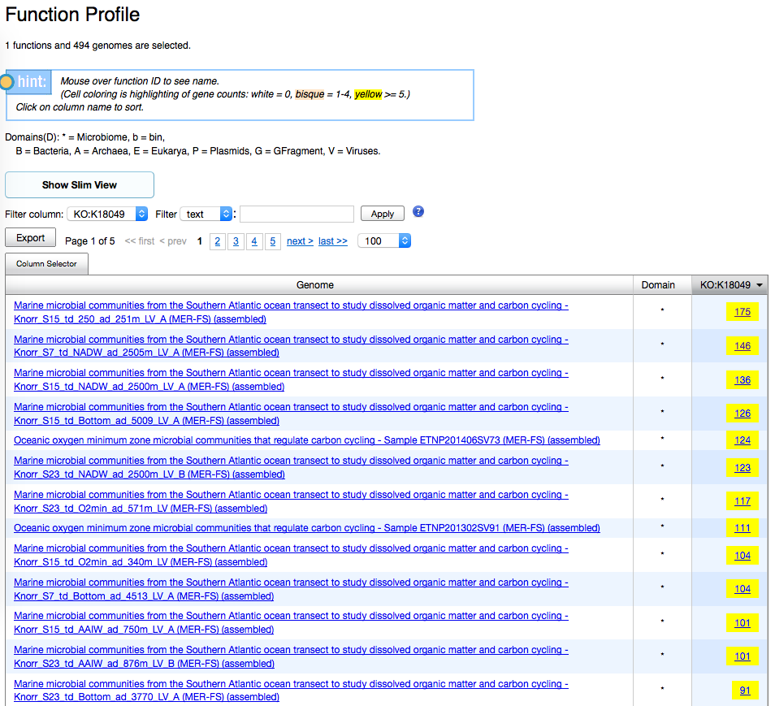

**Result:** A BLAST search using the *N. maritimus* SCM1 methylphosphonate synthase (*mpnS*) successfully uncovered a homolog in another numerically dominant marine microbe, *Candidatus* Pelagibacter (aka SAR11). A wide search across 401 oceanic metagenomes recovered many more homologs, with the largest number of 175 in a single metagenome.